Type in the address below in the address bar of a web browser such as Internet Explorer, Chrome or Firefox,

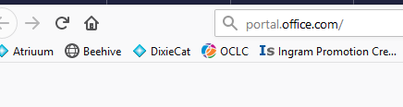

The screen shown below will come up.

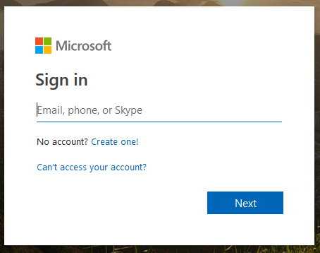

Type in your complete email address. (i.e. drls@dixie.lib.ms.us)
Then type in your password and Sign in.

