October 2017
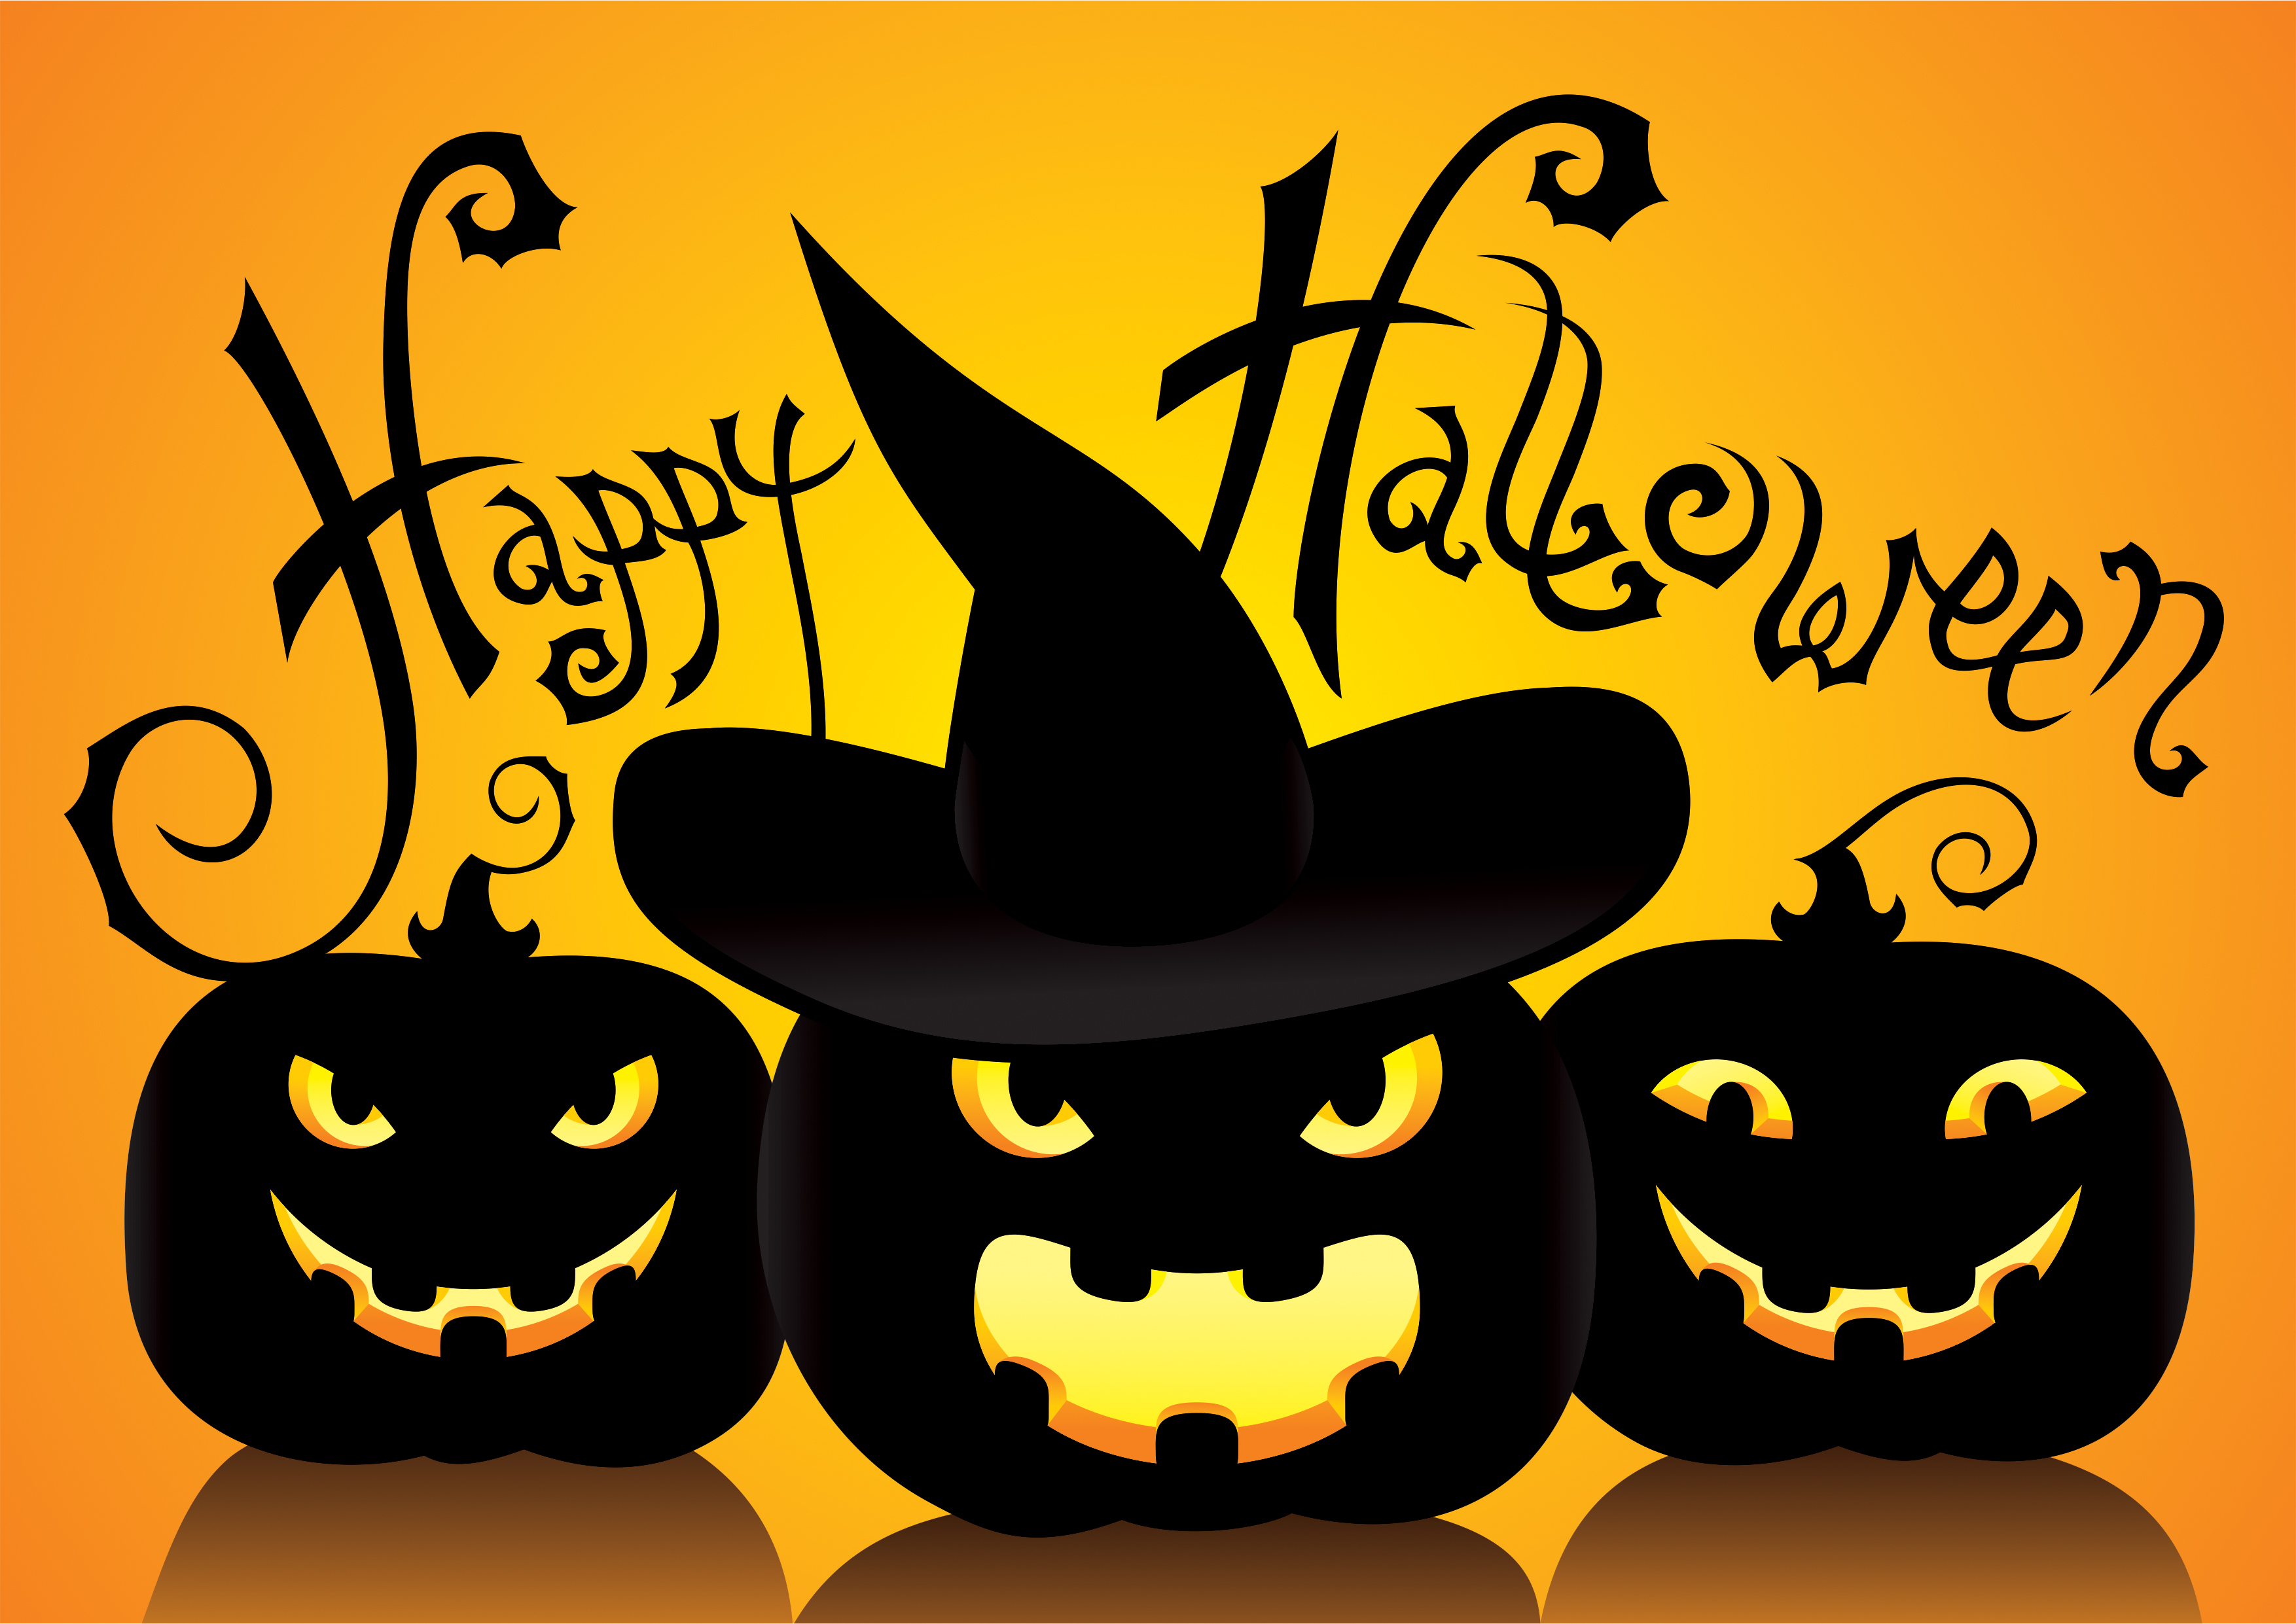
Pontotoc County Library
Calendar of Events
1
2
3
4
5 10:00 Storytime – Apples and Pumpkins and Eating Apples
5 David Shannon’s Birthday
6 6:00 Dulcimers
7
8 R.L. Stine’s Birthday
9
10
11
12 10:00 Storytime – Patty’s pumpkin patch
13 12:00 Lunching With Books Aylisa Steele Delta jewels
13 1:00 Friends of the Library Meeting (Steak Fundraiser Planning Meeting)
13 7:00 Historical Society Meeting
14
15
16 National Bosses Day
17
18
19 10:00 Storytime – The Spooky Halloween surprise
20 6:00 Dulcimers
21
22 Make a Difference Day
23 Laurie Halse Anderson’s Birthday
24
25 9:00 FALL WALK
26 10:00 Storytime “Halloween Party”
27
28 11:00 – STEAK FUNDRAISER ON THE COURT SQUARE
28 National Chocolate Day
29
30 National Candy Corn Day
31 HALLOWEEN

